# Requirements for Custom Lens

## Introduction

We are seeking two copies of a custom lens. They will be used on a robot that is designed to model the visual and visuomotor systems of the macaque monkey. The robot will be used for research in computational neuroscience of vision. Like humans, monkeys have much higher acuity at the centre of the visual field than the periphery. We would like a lens that approximates this acuity by distributing light from a small central part of the visual field to a relatively large fraction of a standard sensor. The size and inertial properties of the lens are also important.

## General Requirements:

* Large variation in magnification from centre to periphery
* Small and light
* Rapid variable focus

## Detailed Requirements:

The lenses **must**:

1. Be compatible with the Point Grey Flea3 1.3 MP color USB 3.0 camera:

* 1/3” sensor format
* 3.63 um pixel size
* CS-mount

1. Have a field of view of at least 90 degrees
2. Have much higher magnification in the centre than the periphery (see below)
3. Have mass no greater than 80g
4. Have a variable, electronically controllable focus distance between 30cm and infinity
5. Refocusing at any distance in this range within 150ms
6. Cost at most $25,000 USD plus tax, including the design and manufacture of two lenses.

The lens should ideally:

1. Have a mass no greater than 40g
2. Have dimensions not exceeding 52 mm axial length, 38 mm diameter
3. Have a field of view of 120-180 degrees
4. Follow one of the distortion curves given below

## Notes

1. To achieve variable focus, we suggest that the design incorporate the Varioptic variable focus liquid lens: <http://www.varioptic.com/products/variable-focus/>
2. The customer should own the lens design. We would like to publish it openly, along with the design of the rest of the robot.

## Field-of-View Alternatives

The lens would ideally have a 180° field-of-view. However, we are aware that this may not be possible within other constraints. The diagrams below characterize four different alternatives (in order of preference): 180°, 150°, 120°, and 90°. Note that qualitatively the percent distortion decreases with decreasing FOV.

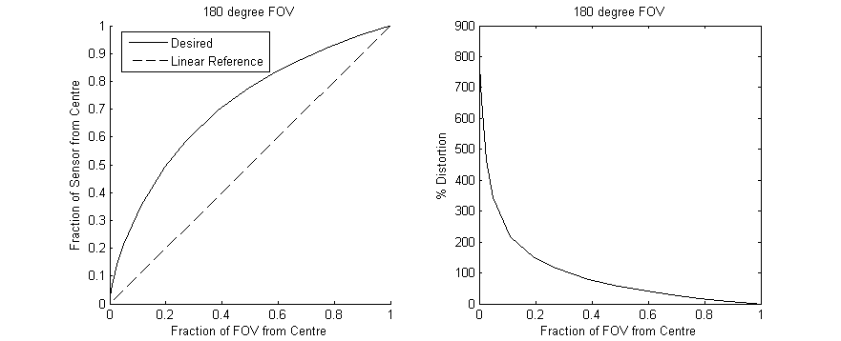

Figure 1: Variation of the lens magnification from centre to edge for the 180° field-of-view option. This is the preferred option if it is feasible within other constraints. Left: Cumulative linear fraction of sensor as a function of fraction of field of view. Right: Percent distortion, i.e. 100(FractionSensor/FractionFOV-1).

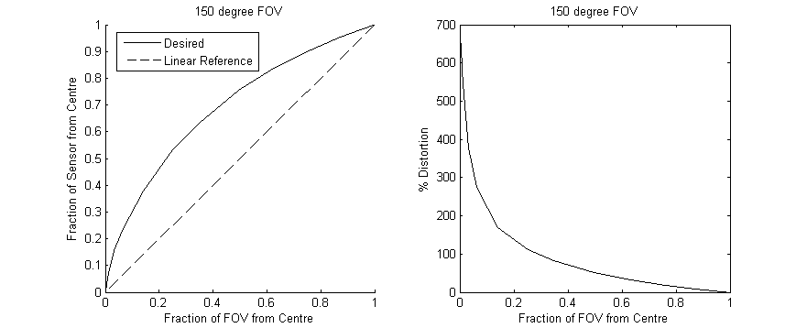

Figure 2: As figure 1 for the 150° field-of-view option.

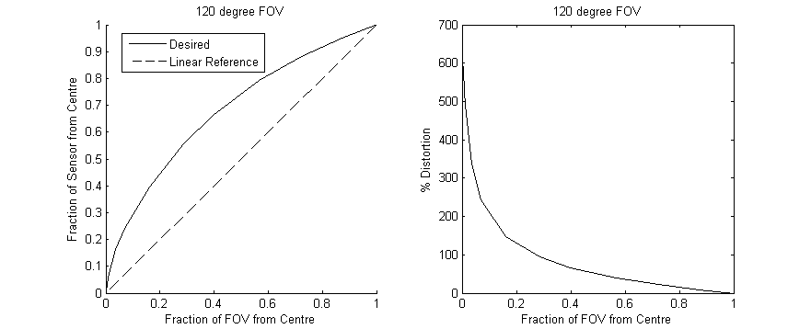

Figure 3: As figure 1 for the 120° field-of-view option.

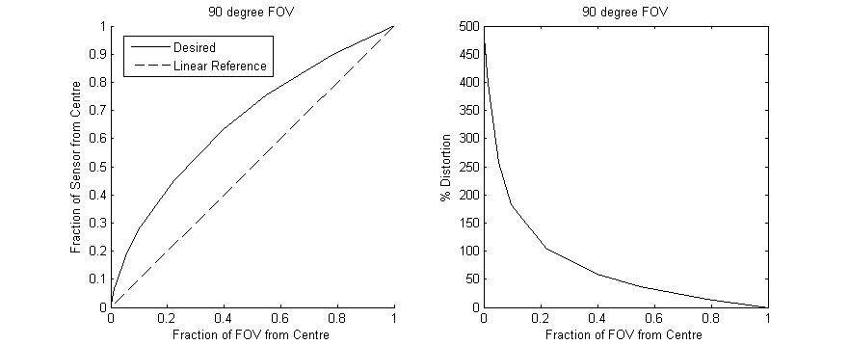

Figure 4: As figure 1 for the 90° field-of-view option.